Master Startup Process – tractor using ROSAg

$ roslaunch /home/tractor/catkin_ws/src/nmea_navsat_driver/launch/nmea_to_odom.launch
tractor@tractor-HP-ProBook-645-G1:~$ rostopic list
/fix
/heading
/imu/data
/joint_states
/odom
/rosout (from roscore)
/rosout_agg (from roscore)
/speed
/tf
/tf_static
/time_reference
/vel
tractor@tractor-HP-ProBook-645-G1:~$

$ roslaunch /home/tractor/catkin_ws/src/lawn_tractor_sim/launch/ros1_navigation.launch
tractor@tractor-HP-ProBook-645-G1:~$ rostopic list
rostopic list
/clicked_point
/current_goal
/fix
/heading
/imu/data
/initialpose
/joint_states
/map
/map_metadata
/move_base/cmd_vel
/move_base_flex/GlobalPlanner/parameter_descriptions
/move_base_flex/GlobalPlanner/parameter_updates
/move_base_flex/GlobalPlanner/plan
/move_base_flex/GlobalPlanner/potential
/move_base_flex/TebLocalPlannerROS/global_plan
/move_base_flex/TebLocalPlannerROS/local_plan
/move_base_flex/TebLocalPlannerROS/obstacles
/move_base_flex/TebLocalPlannerROS/parameter_descriptions
/move_base_flex/TebLocalPlannerROS/parameter_updates
/move_base_flex/TebLocalPlannerROS/teb_feedback
/move_base_flex/TebLocalPlannerROS/teb_markers
/move_base_flex/TebLocalPlannerROS/teb_poses
/move_base_flex/TebLocalPlannerROS/via_points
/move_base_flex/current_goal
/move_base_flex/exe_path/cancel
/move_base_flex/exe_path/feedback
/move_base_flex/exe_path/goal
/move_base_flex/exe_path/result
/move_base_flex/exe_path/status
/move_base_flex/get_path/cancel
/move_base_flex/get_path/feedback
/move_base_flex/get_path/goal
/move_base_flex/get_path/result
/move_base_flex/get_path/status
/move_base_flex/global_costmap/costmap
/move_base_flex/global_costmap/costmap_updates
/move_base_flex/global_costmap/footprint
/move_base_flex/global_costmap/parameter_descriptions
/move_base_flex/global_costmap/parameter_updates
/move_base_flex/global_costmap/static_layer/parameter_descriptions
/move_base_flex/global_costmap/static_layer/parameter_updates
/move_base_flex/local_costmap/costmap
/move_base_flex/local_costmap/costmap_updates
/move_base_flex/local_costmap/footprint
/move_base_flex/local_costmap/obstacle_layer/parameter_descriptions
/move_base_flex/local_costmap/obstacle_layer/parameter_updates
/move_base_flex/local_costmap/parameter_descriptions
/move_base_flex/local_costmap/parameter_updates
/move_base_flex/move_base/cancel
/move_base_flex/move_base/feedback
/move_base_flex/move_base/goal
/move_base_flex/move_base/result
/move_base_flex/move_base/status
/move_base_flex/parameter_descriptions
/move_base_flex/parameter_updates
/move_base_flex/recovery/cancel
/move_base_flex/recovery/feedback
/move_base_flex/recovery/goal
/move_base_flex/recovery/result
/move_base_flex/recovery/status
/move_base_simple/goal
/odom
/rosout
/rosout_agg
/scan
/speed
/tf
/tf_static
/time_reference
/vel
tractor@tractor-HP-ProBook-645-G1:~$

To debug, $ rqt_graph

Interesting post about programming position goals
https://automaticaddison.com/how-to-send-goals-to-the-ros-navigation-stack-using-c/#:~:text=Open%20a%20new%20terminal%20to%20launch%20the%20nodes.,your%20first%20goal%20to%20the%20ROS%20Navigation%20Stack.

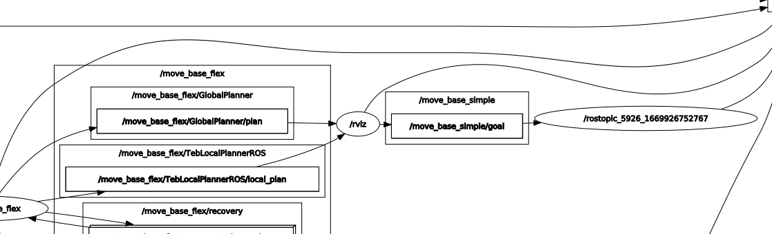

move_base_simple/goal does not appear to be going anywhere

